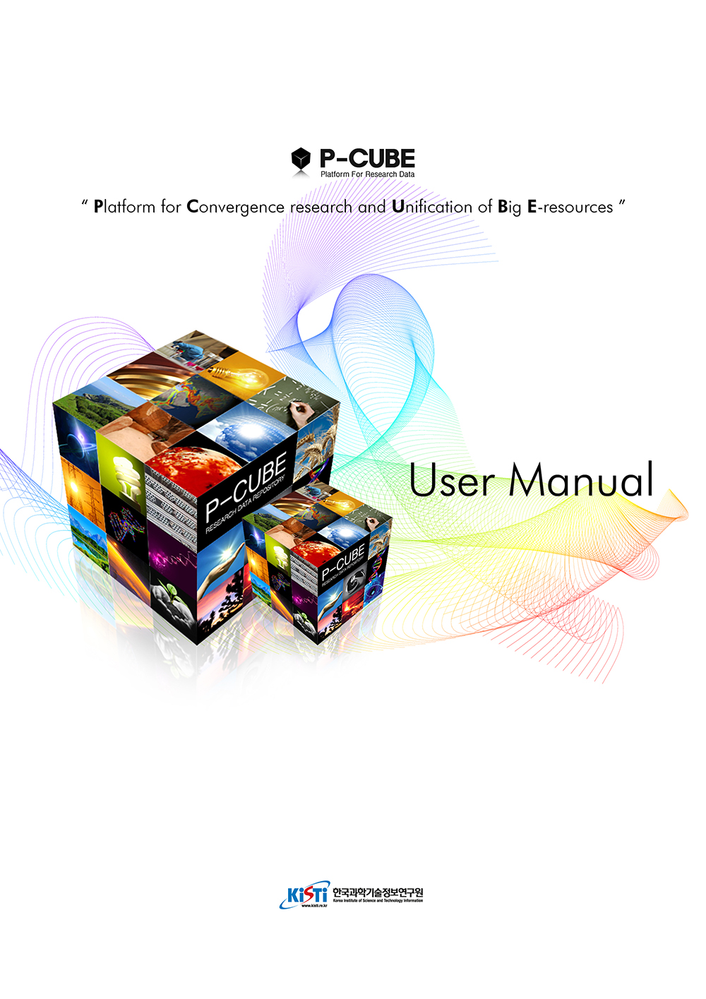

Table of contents

**Chapter 1 : User registration and profile management** 1

**User registration** 1

**Log-in** 3

**Find a password** 4

**Profile Management** 5

**Chapter 2 : Integrated search and detailed search** 7

**Integrated Search** 7

**Detailed Search** 8

**Chapter 3 : A browse** 9

**Organization and Collection browse** 10

**Approval date browse** 11

**Author browse** 12

**Title browse** 13

**Browse by subject classification** 14

**Chapter 4 : MY CUBE** 16

**Item Submission List** 16

**Item Approval List** 17

**New submission of an item** 19

**Items for verification** 25

**Chapter 5 : P-DRIVE** 29

**What is P-DRIVE?** 29

**Chapter 1 : User registration and profile management**

**User registration**

**User should be registered in advance for submitting an item at P-CUBE.**

1. Click "registration" on the top of the main page of P-CUBE to move to "User Registration" window.
2. Input an e-mail address and click "registration" button, then "P-CUBE : Membership Notification" e-mail will be sent to the e-mail input.

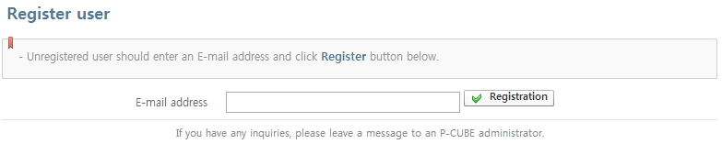

The e-mail address you input is used as an user ID and e-mail address at P-CUBE. There fore you should input an accurate address.

1. Clicking URL from the "P-CUBE : Admission Notification" e-mail, it will move to " Member Registration" window.

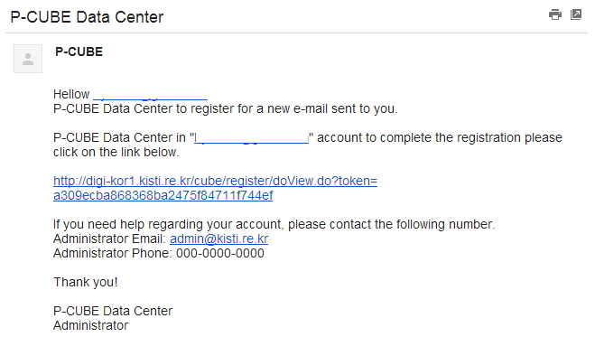

1. After inputting information of a user, click "Save Content Input" to finish user registration.

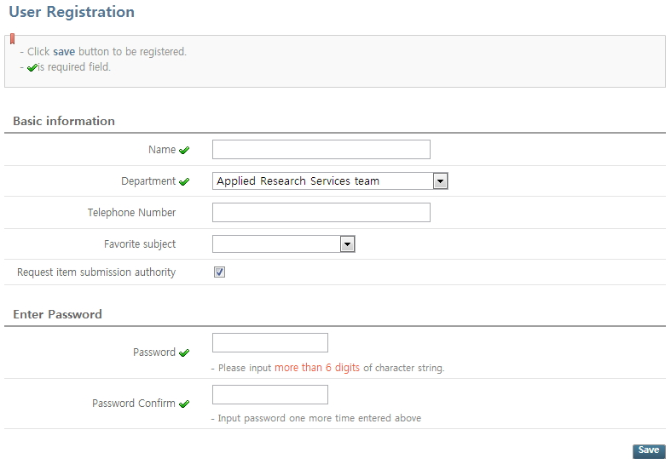

Name, department, password, and pwassword check are field of required input.

**Log-in**

**Similar to Log-in from general website, you can log-in with the e-mail and the password input when registered.**

1. Input password in the log-in input form on the top left to the main page of P-CUBE.

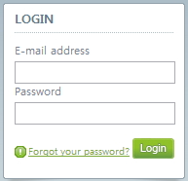

If you forgot your password, click "Forgot your password" link.  
If you forgot your password input when registered, you should refer to administrator directly.

**Find a password**

**when you forgot your password, password edit webpage URL will be supported.**

1. If you click "Forgot your password" link, the "find your password" window will be displayed as picture below.
2. Input the e-mail address input registered when joining.

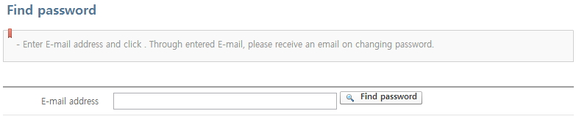

1. An e-mail will be sent to your input e-mail address, and sent e-mail includes URL that can set a password.

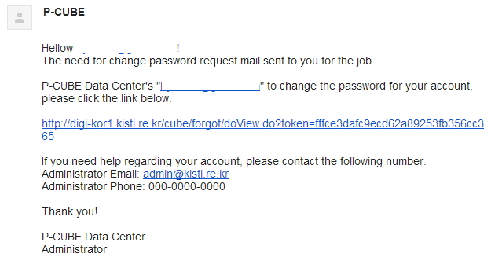

1. Clicking URL included, the window below will be displayed. Please input new password.

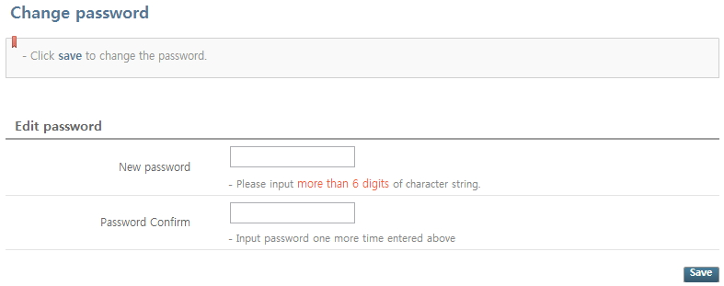

**Profile Management**

**It supplies basic information edit function of a user. The authority of affiliated group and the user can be checked on.**

1. Click "profile management" of log-in domain at the main screen of P-CUBE.
2. Basic information of a user, password edit, affiliated group, and information of authority can be checked.

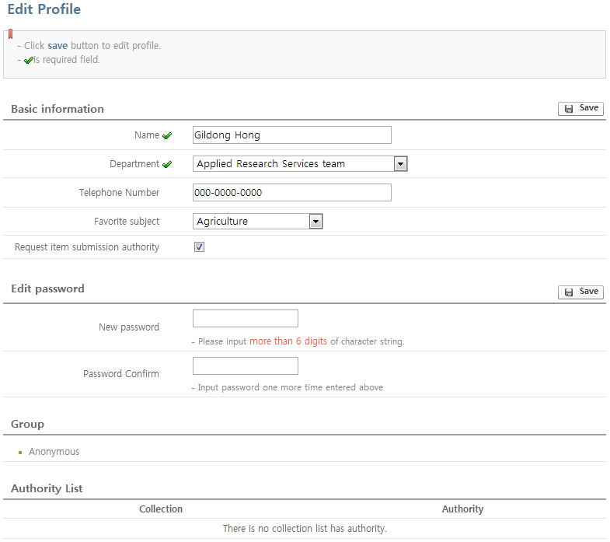

Affiliated group : Group except for anonymous group is attached by administrator.  
Authority List : It is assigned by administrator. The receivable authority are 'Item Submission'/'Item Verification'/'Item Access'

**Chapter 2 : Integrated search and detailed search**

**Integrated Search**

**Integrated Search searches and supplies the results of title, author, and subject of an item, based on the keyword input.**

1. If you wish to use integrated search of P-CUBE, use search window on the top of the page.

https://raw.github.com/hyonani/pcube/master/WebContent/images/search1_eng.jpg

1. Click detailed search link when you need to search something restricted to a certain organization and collection.

**P-CUBE uses Jakarta Lucene as search engine, and includes search functions below.**  
1) The contents input into keywords allows searching for title, author and subject of an item.  
2) Words as below are ignored among search keywords.  
E.g.) "a", "and", "are" , "as" , "at" , "be" , "but" , "by" , "for" , "if" , "in" , "into", "is" ,"it" ,"no" , "not" , "of" , "on" , "or" , "such", "the" , "to" , "was"  
3) Keyword with (*) special symbol behind, it searches all words which contain the keyword.  
E.g.) select* search results : selects, selector, selectman, selecting  
4) If you wrap keyword with ("). It searches multiple keywords.  
E.g.) "organization change"  
5) If you put (+) special symbol in front of a keyword, items with this keyword must show up in the results.  
E.g.) +dog training  
6) Putting (-) special symbol in front of a keyword, items with this keywords are excluded from the results.  
E.g.) dog -training  
7) Searching multiple keywords and input 'AND' inbetween them, items which have two keywords together will be shown in the results.  
E.g.) dog AND training  
8) Searching multiple keywords and input 'OR' inbetween them, items with only one keyword will be shown in the search results.  
E.g.) dog OR training

**Detailed Search**

**Basically P-CUBE searches for whole items. And using detailed search, it searches limited to certain orgainizations with limited conditions.**

1. You can search with limited search range to certain organizations, and also with certain search fields such as title, author, subject, map coordinate scope and etc.

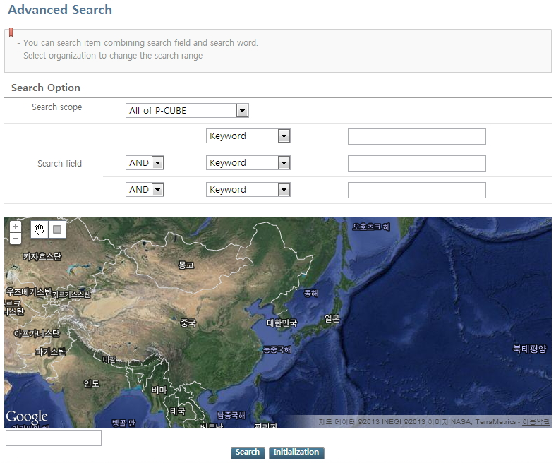

Same with integreted search, you can combine keywords using Boolean operator.  
The search is not completed when the first keyword input form is empty.

**Chapter 3 : A browse**

**Organization and Collection browse**

**You can search an item by organization or collection**

1. Click "browse > organization & Collection" menu on the left of the window to search collection lists.

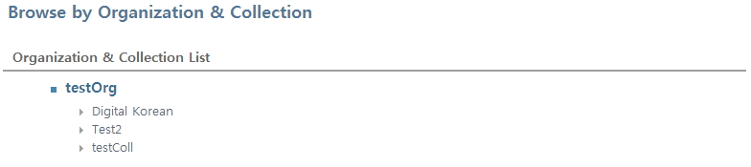

1. Clicking a certain organization or collection will show you the item lists submitted along with sub-organization and collection.
2. Detailed window of organization and collection provides several functions for item search.

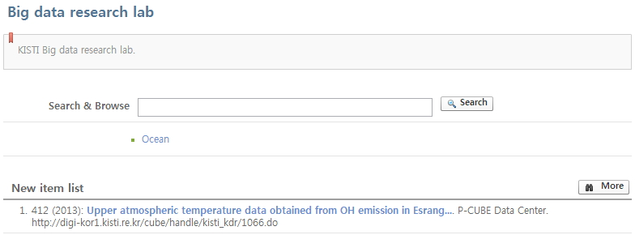

Item lists submitted to a related organization with search and browse can be checked.  
You can browse items by sub-organization & collection unit.  
You can check datas through "view more" button more than eight datas offered basically.

1. You can print current item information using "print" button on all detailed screen of item for item browse, and save basic information of current item as text or excel file using "exporting" button.

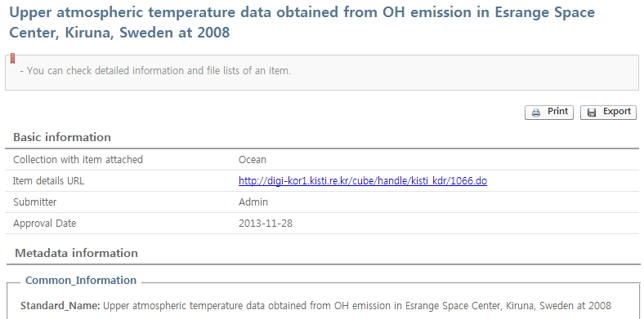

1. If there are NDSL theis papers linked to an item title on item detailed screen, "related NDSL paper" will be shown on the bottom of item detailed screen.
2. Information page of NDSL paper will be shown clicking the title of NDSL paper.

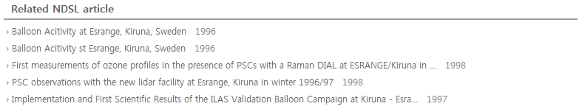

**Approval date browse**

**Item can be searched by approval date (time of completed verification).**

*Approval date is defined as the time completed verification of attached files and metadata of item from verifiers after submitting an item by user.*

1. You can search item by year or month.
2. Approval date, submitted date, title search and alignment about the results can be performed.
3. Click a certain item on the list to move item detailed screen.

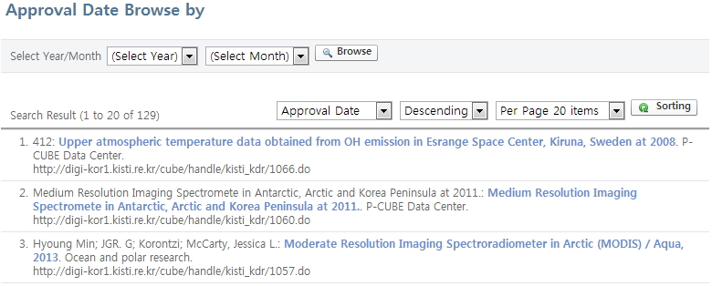

**Author browse**

**To check the status of item submitted by author, you can search an item by author basis.**

1. You can search author by the first letter of the author, or keyword input.
2. Alignment function can be used for the search result of author.

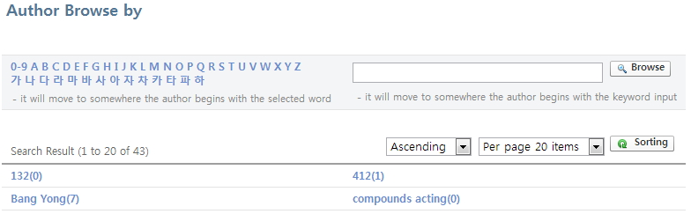

1. You can check item list of related author, clicking a certain author on the list.

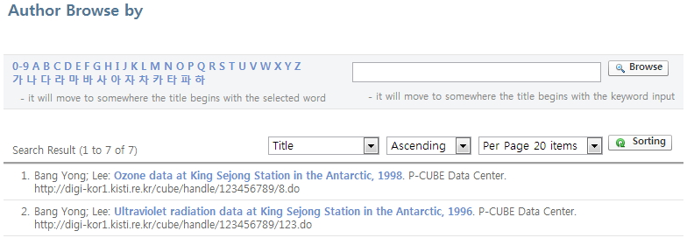

**Title browse**

**Items can be searched in order of item titles.**

1. Items can be searched with keywords or the first letter of item titles.
2. You can arrange the search results based on title, the final date of approval, date of submission and etc of the search results.
3. If you click on certain item from the list, it will move to the detailed screen of items.

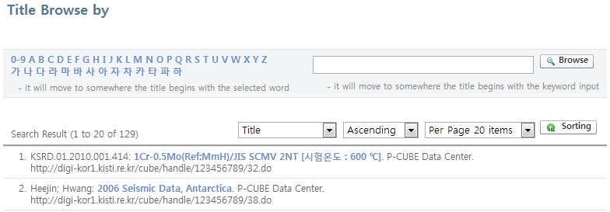

**Browse by subject classification**

**You can search an item by subject classification.**

1. Clicking a certain subject on subject classification list, item lists of submitted relating subject will be shown.

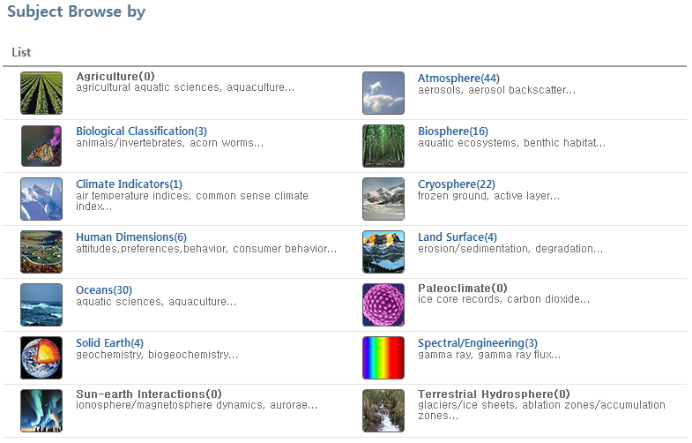

1. You can arrange the search result by title, the final date of approval, submission date bais.

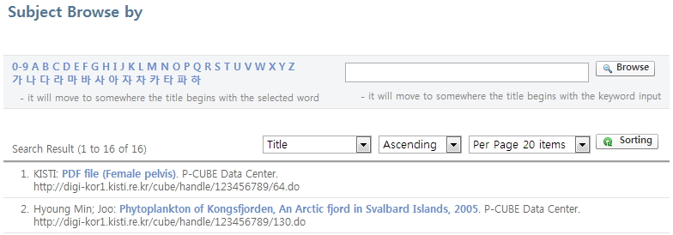

The subject classification is set by administrator. Please refer to administrator for more details.

**Chapter 4 : MY CUBE**

**Item Submission List**

**You can search items under submission and waiting for approval after submission.**

**Item unfinished submission can be continued submitting or deleting, along with additional work such as submitting cancellation on item waiting for approval after submission.**

1. " item under submission", "item waiting for approval after submission" list can be checked.
2. Click "new item submission" button to move "new submission of item" screen.
3. You can delete an item under submission using "delete" button on the list of "item under submission".

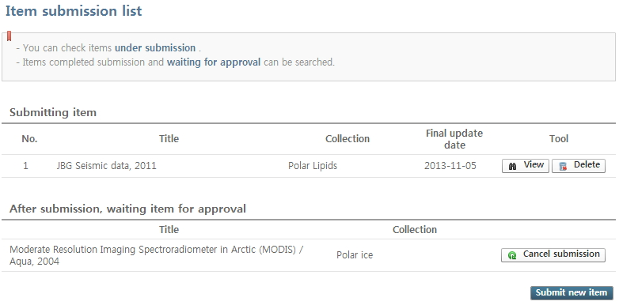

"Item under submission" can be check on the item list of state of 'item under submission'.  
"Item waiting for approval after submission" is an item waiting for verifier approval of collection submitted, after completion of submission.

1. You can contine deleting or submitting related items by clicking "view" button on "item under submitting" list.

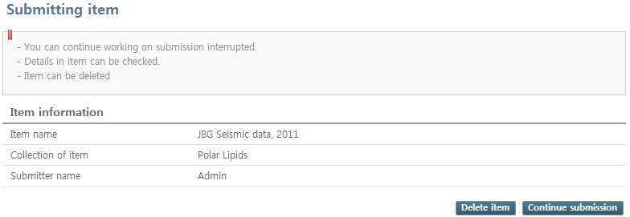

1. Clicking "submission cancellation" button on "item waiting for approval after submitting" list, the item of the state of submission completed will be changed to item under submission. And the related item will be moved to the list of items of under submission.

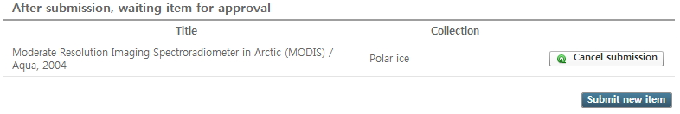

**If the verifier is working on verifying an item, "Cancellation submission" button will be disactivated.**

**Item Approval List**

**You can search the list of items which finished its approval. Those items are open to other users as search and browse function.**

1. Click "Approval list of item" on the left menu to check the item list submitted as below.

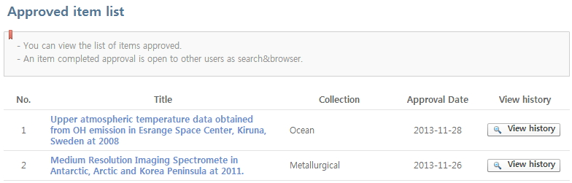

1. click a certain item on the list to move to item detailed screen.

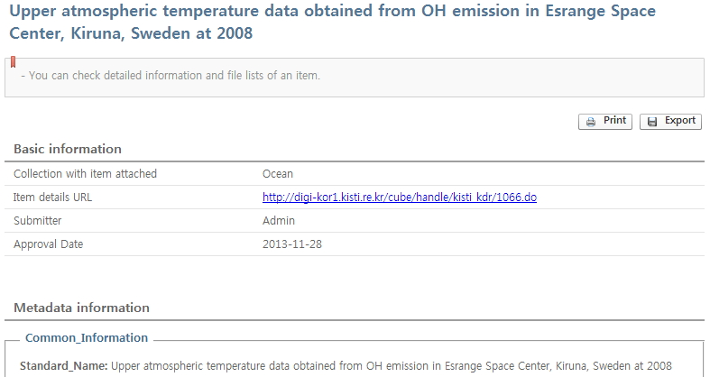

1. Detailed history on submission and verification of the item will be shown by clicking "View history" of an item.

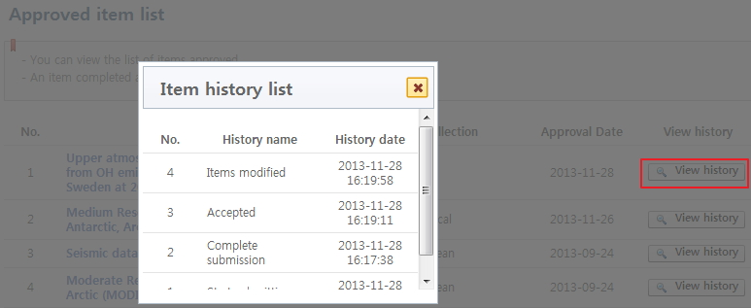

**New submission of an item**

**The new submission of an item is completed through input tasks in several stages such as setting basic information, inputting metadata, and submitting attached files.**

1. Select collection, click "next stage >" button. Then it will move to "basic setting" screen.  
   If you have submitted an item similar to the one to be submitted, you can submit an item easily reusing metadata of the item submitted.

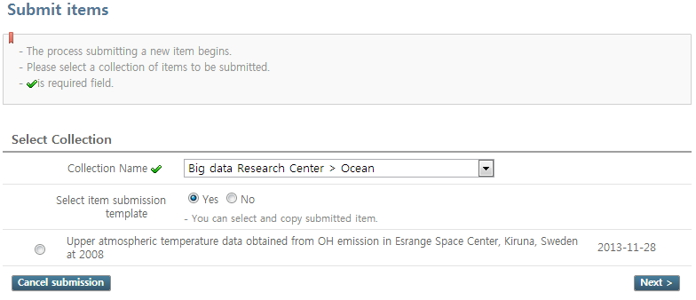

**Utilization method of existing item submitted**  
1) Search list of existing item submitted from current collection, selecting "yes" to "Select item submission templet".  
2) Select an item to use and click "next stage" button. Then the metadata of related item will be applied to a newly submitted item.

1. Setting for subject, disclosure, harvesting, DOI, and standard classification of science and technology of an item can be performed on "basic setting" screen.

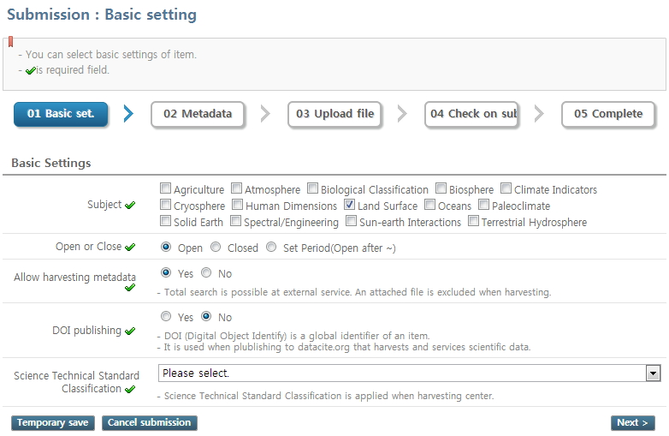

Peferred subject classification of user is selected elementarily for subject classification, and several subject classification can be selected.  
If changing the date to "period setting" for opening to the public or not, it will go public after the date selected.  
Integrated search is possible at external service after allowing harvesting metadata. The original data (attatched file) is excluded from harvesting.  
"DOI" (Digital Object Identify) as a global identifier of an item, is used for metadata publication at "datacite.org", selecting " DOI Granting".  
Standard classification of Science and Technology is a classification applied when harvesting.

1. You can input metadata of an item on "metadata" screen.  
   You can input into required fields of metadata easily, selecting "compulsory view". You can add and delete metadata fields which are repeatable with + and - button of metadata.

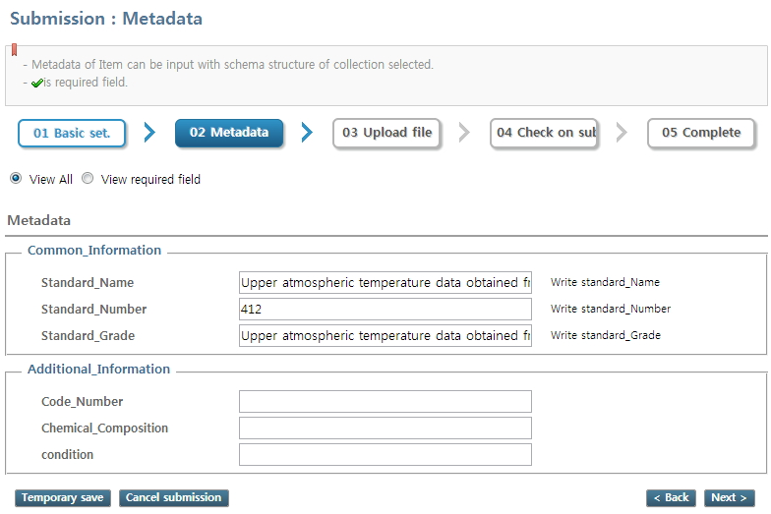

If you wish to continue where you stopped submission task, please click the "temporary storage" button of each item submission stage at the left bottom.  
Item stopped submission can be checked at "item submission list" of "MY CUBE > item submission list" screen from the menu on the left.

1. You can select attached file related to the item from the first screen of "file upload". If there is no file to attach, click "next stage>" button to skip this step.

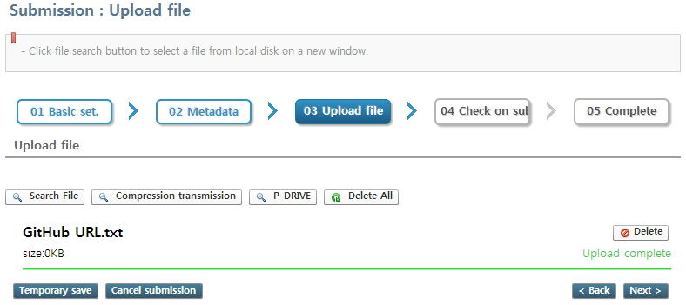

You can register several files at once by dragging several files or folders at window explorer.  
(It is only operated at browsers which support HTML 5 as IE10, Chrome, Firefox and etc.)  
If there is no file attached, click "next step >" button to move to a screen for checking files uploaded.

1. You can edit on format and description of attached file at the second screen of the "file upload".

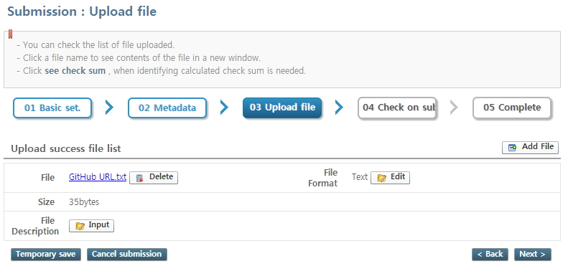

You can delete the related file, clicking "delete" button.  
File format is automatically recognized by system. You can edit file format if the file format is wrong or you wish to edit.  
You can register a file description and edit the description input. The file description is indexed and used for keyword search.

1. You can check the information of basic setting, metadata, and attached file on "submission information check" screen at previous stage.   
   If there is no error on information of item, click "next stage >" button to finish submission.

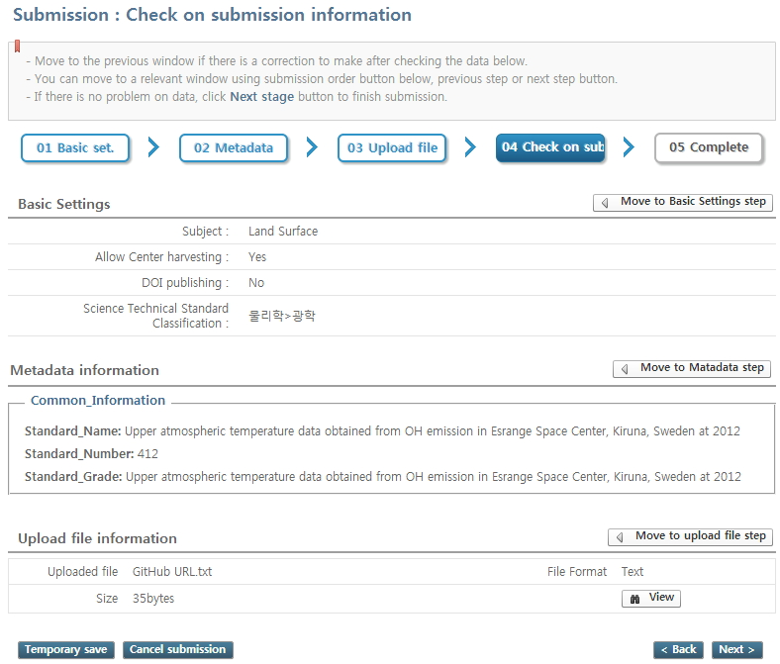

If you click buttons of each stage, it will move to the stage related to continue inputting work.

**Items for verification**

**Only 'a verifier or a representative verifier' appointed by administrator according to its collections can use this function.**  
**'A verifier' can add comment of verification, and 'representative verifier' can perform 'item approval or rejection' refering to the comment of 'verifier'.**

1. Clicking "Item for verification" on the left menu, then the screen will be shown as follows.

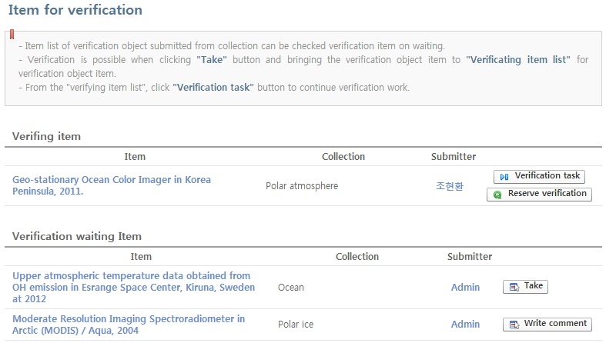

"Writing an opinion" button of an item waiting for verification only shows to verifiers.  
"Bring" button of an item waiting for verification only shows to verifiers.

1. Click "writing an opinion" button from the list of item waiting for verification to move to a screen writing a verification opinion on the related item.

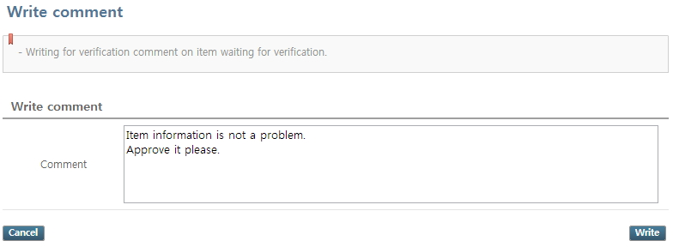

1. Opinion on written item can be checked as below.

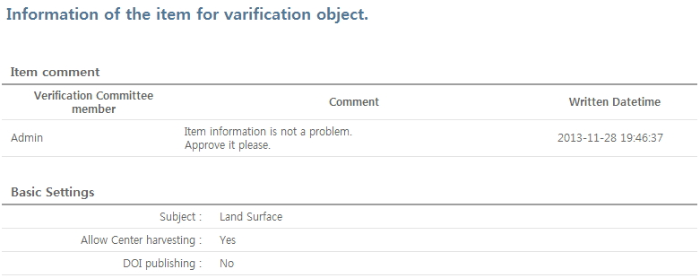

If you write a verification opinion, the number of opinions written on the name of related item from "item waiting for verification".

1. Click "Bring" button from the list of item waiting for verification to move to screen of "verification task" screen.

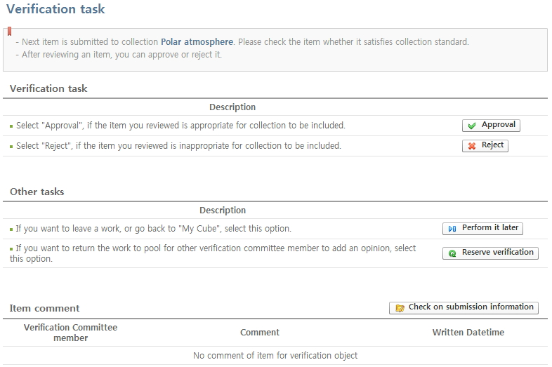

Verfication task : It selects approval and rejection of verification.  
- Click "Approval" button and approve the verification of the related item.  
- click "Rejection" button and disapprove the verification of the related item. Then, it will return to the state of submission.  
Other Work : It is used when one wants to use it next time instead of verifying it right way.  
- leave the related item in the state of verifying, with clicking "Working on later" button.  
- Click "suspension of verification" button and leave the related item in the state of waiting for verification.

1. If you approve, the related item will be finished verification, and you can check it thorugh search browse function.

For items set as the 'nondisclosure' or which still has time left until its' 'set date of going on public', it is open to other users.

**Chapter 5 : P-DRIVE**

**What is P-DRIVE?**

**P-DRIVE supports users with individual storage space for file save and management.**  
**It is easier for users to use uploading a huge file which is hard to upload directly when submitting an attached file.**

1. The screen as below will be shown, clicking "P-DRIVE" on the left menu. When registering an external file which takes longer time downloading, P-CUBE saves and downloads the file to P-DRIVE.

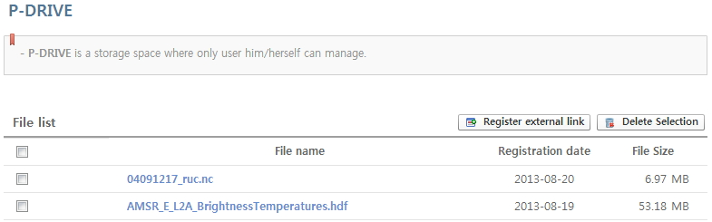

1. By clicking "external link registration" button, the 'external linked file registration" window will pop up. Clicking "File Registration" button after inputting HTTP or FTP linked address of a file to be downloaded, the file at related location will be registered to P-DRIVE.

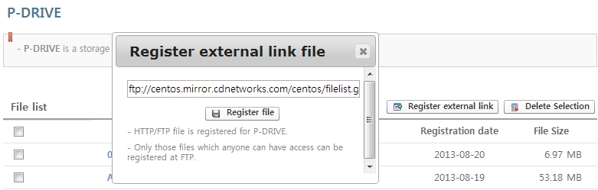

1. Click "P-DRIVE" button to use a file of user saved at "P-DRIVE" on screen of file upload under submitting an item.

